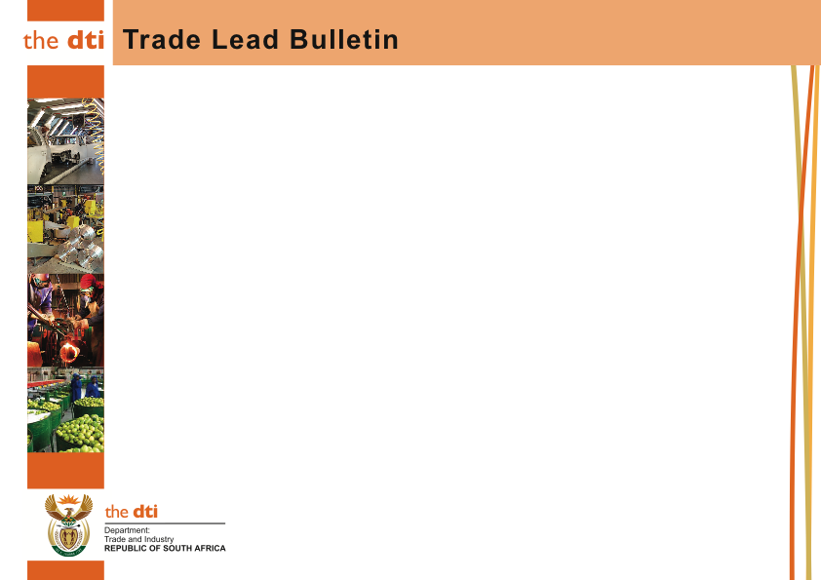
REFERENCE NUMBER | DATE RECEIVED | OFFICIAL’S DETAILS | NATURE OF ENQUIRY | ORIGINATING COUNTRY
ASIA
1653 | 10//08/2015 | Yollanda Didishe (Ms) Assistant Director: Trade Opportunities 77 Meintjies Street, Sunnyside, 0002 Private Bag x84 Pretoria 0001 Tel: +27 12 394 1018 Fax: +27 12 394 2018 E-mail:tradeleadbulletin@thedti.gov.za | Products Required: Lentils  Specification: Not Available  Quantity Required: 120 Metric Tons Frequency: Bi-monthly  Destination Port: Colombo, Sri Lanka  Expiry Date:10 September 2015 |  | Sri Lanka
1654 | 13/08/2015 | Yollanda Didishe (Ms) Assistant Director: Trade Opportunities 77 Meintjies Street, Sunnyside, 0002 Private Bag x84 Pretoria 0001 Tel: +27 12 394 1018 Fax: +27 12 394 2018 E-mail:tradeleadbulletin@thedti.gov.za | Products Required: Cashew Nuts  Specification: Not Available  Quantity Required: Not Available  Frequency: Not Available Destination Port: Not Available  Expiry Date: 10 September 2015 |  | South Korea

Disclaimer: the dti will not accept responsibility for the reputation or standing of individuals or firms mentioned in this bulletin and anyone who utilizes this bulletin indemnifies the dti against any loss or damage suffered as a result

.

Thurs, 03 Sept 2015
EFERENCE NUMBER | DATE RECEIVED | OFFICIAL’S DETAILS | NATURE OF ENQUIRY | ORIGINATING COUNTRY
ASIA
1655 | 19/08/2015 | Yollanda Didishe (Ms) Assistant Director: Trade Opportunities 77 Meintjies Street, Sunnyside, 0002 Private Bag x84 Pretoria 0001 Tel: +27 12 394 1018 Fax: +27 12 394 2018 E-mail:tradeleadbulletin@thedti.gov.za | Products Required: Coal  Specification: Not Available  Quantity Required: 2 250 00 Metric Tons  Frequency: Annually  Destination Port: Colombo, Sri Lanka  Expiry Date: 10 September 2015 | Sri Lanka
1656 | 28/08/2015 | Yollanda Didishe (Ms) Assistant Director: Trade Opportunities 77 Meintjies Street, Sunnyside, 0002 Private Bag x84 Pretoria 0001 Tel: +27 12 394 1018 Fax: +27 12 394 2018 E-mail:tradeleadbulletin@thedti.gov.za | Products Required: Cashew Nuts  Specification: Not Available  Quantity Required: Not Available  Frequency: Not Available  Destination Port: Mumbai, India  Expiry Date: 10 September 2015 | India

Disclaimer: the dti will not accept responsibility for the reputation or standing of individuals or firms mentioned in this bulletin and anyone who utilizes this bulletin indemnifies the dti against any loss or damage suffered as a result

.

Thurs, 03 Sept 2015
REFERENCE NUMBER | DATE RECEIVED | OFFICIAL’S DETAILS | NATURE OF ENQUIRY | ORIGINATING COUNTRY
ASIA
1657 | 26/08/2015 | Yollanda Didishe (Ms) Assistant Director: Trade Opportunities 77 Meintjies Street, Sunnyside, 0002 Private Bag x84 Pretoria 0001 Tel: +27 12 394 1415 Fax: +27 12 394 2415 E-mail:tradeleadbulletin@thedti.gov.za | Products Required: Frozen Seafoood  Specification: Not Available  Quantity Required: 100kg  Frequency: Quarterly Destination Port: Singapore  Expiry Date: 10 September 2015 | Singapore

Disclaimer: the dti will not accept responsibility for the reputation or standing of individuals or firms mentioned in this bulletin and anyone who utilizes this bulletin indemnifies the dti against any loss or damage suffered as a result

.

Thurs, 03 Sept 2015
REFERENCE NUMBER | DATE RECEIVED | OFFICIAL’S DETAILS | NATURE OF ENQUIRY | ORIGINATING COUNTRY
EUROPE
1658 | 17/08/2015 | Yollanda Didishe (Ms) Assistant Director: Trade Opportunities 77 Meintjies Street, Sunnyside, 0002 Private Bag x84 Pretoria 0001 Tel: +27 12 394 1018 Fax: +27 12 394 2018 E-mail:tradeleadbulletin@thedti.gov.za | Products Required: Almonds, Cashew and Macadamia Nuts, Dried Fruits and Raisins  Specification: (Almonds Size 23/25 Cashews WW320, SW320 Macadamia 0,1,2,)  Quantity Required: 1 Container  Frequency: Not Available Destination Port: Hamburg and Rotterdam  Expiry Date: 10 September 2015 | Prague- Czeck

Disclaimer: the dti will not accept responsibility for the reputation or standing of individuals or firms mentioned in this bulletin and anyone who utilizes this bulletin indemnifies the dti against any loss or damage suffered as a result

.

Thurs, 03 Sept 2015
REFERENCE NUMBER | DATE RECEIVED | OFFICIAL’S DETAILS | NATURE OF ENQUIRY | ORIGINATING COUNTRY
MIDDLE EAST
1659 | 18/08/2015 | Yollanda Didishe (Ms) Assistant Director: Trade Opportunities 77 Meintjies Street, Sunnyside, 0002 Private Bag x84 Pretoria 0001 Tel: +27 12 394 1018 Fax: +27 12 394 2018 E-mail:tradeleadbulletin@thedti.gov.za | Products Required: Acrylic Staple Fibre and Acrylic Tow Fibre  Specification: 5.6 dtx, 8.9dtx, 5-8den and dyed 2.8tx, Bright or Semi Dull (Length 102 – 152 MM  Quantity Required: Not Available  Frequency: Not Available Destination Port: Bandar Abass  Expiry Date:10 September 2015 | Iran
1660 | 17/08/2015 | Yollanda Didishe (Ms) Assistant Director: Trade Opportunities 77 Meintjies Street, Sunnyside, 0002 Private Bag x84 Pretoria 0001 Tel: +27 12 394 1018 Fax: +27 12 394 2018 E-mail:tradeleadbulletin@thedti.gov.za | Products Required: White Cotton Fibre  Specification: 100%  Quantity Required: 500 Metric Tons  Frequency: Monthly Destination Port: Khorfakan  Expiry Date: 10 September 2015 | Dubai

Disclaimer: the dti will not accept responsibility for the reputation or standing of individuals or firms mentioned in this bulletin and anyone who utilizes this bulletin indemnifies the dti against any loss or damage suffered as a result

.

Thurs, 03 Sept 2015

